Experiment Details

|  |  |  |
| --- | --- | --- |
| Department Name | Electrical Dept |  |
| Class | S.Y.B tech |  |
| Semester | III |  |
| Subject Name | DC Machine & Transformers |  |
| Experiment No. | 1 |  |
| Experiment Name | SCOTT CONNECTION |  |

Version History

|  |  |  |  |  |
| --- | --- | --- | --- | --- |
| Sr. No. | Version Number | Created By | Approved By | Date |
| 1 | v1.0 | Priya Yadav | Mrs . Sushmita Sharma | 12/10/2020 |
|  |  |  |  |  |

AIM:

To connect two single phase transformers in Scott connection to obtain a 2 phase supply

THEORY:

|  |  |  |  |
| --- | --- | --- | --- |
| **Sr. No.** | **Device** | **Range** | **Quantity** |
| 1. | Single phase transformers with 86.6% and 50% tap | 230V/115V, 50Hz, 2KVA | 2 |
| 2. | Voltmeter | 0-300V AC | 1 |
| 3. | Loading rheostat | 100 ohm, 9.8A | 2 |
|  |  |  |  |

Three phase balanced supply has three equal voltages with 1200 phase difference. Two phase balance supply has two equal voltages with 900 phase difference.

Scott connection uses the knowledge of phasor addition ac voltages. From 3 phase supply, if we add one voltage and half of another voltage, then the resultant voltage has 90 deg phase difference with respect to the first component. (An example is shown below.)

These two voltages are applied to primaries of the two transformers and transferred to secondary side by transformer action.

**Observation table:**

|  |  |  |  |  |  |  |  |  |
| --- | --- | --- | --- | --- | --- | --- | --- | --- |
| Sr. No. | 3 phase supply voltage V  (Volt) | | | Teaser tfr  voltages | | Main tfr voltages | | Resultant  voltage |
| VRY | VYB | VBR | Primary VTT’ | Secondary Vtt’ | Primary  VYB | VYC | Secondary Vyb | Vtb |
| 1. |  |  |  |  |  |  |  |  |

|  |  |  |  |  |  |
| --- | --- | --- | --- | --- | --- |
| **Sr. No.** | **3 phase currents** | | | **2 phase currents** | |
| **IR** | **IY** | **IB** | **IT** | **IM** |
| **1.** |  |  |  |  |  |

**Calculations:**

1. Referring to phasor diagram,

VTT’= =

=

= 0.866 V

= ……….

For main transformer. primary winding turns = N1

secondary winding turns = N2

and N2 / N1 = 0.5

1. Emf per turn for Teaser transformer =

= Voltage applied between TT’/ Turns included between TT’

= VTT’/0.866N1

=….. …….=…………

1. Emf per turn for Main transformer =

=VYB/N1

=……..

1. Emf induced in teaser secondary = emf per turn * N2= ………….=
2. Emf induced in main secondary = emf per turn * N2=…………=
3. Phase difference between Vtt’ and Vyb

Resultant voltage Vtb = $\sqrt{{V_{tt'}}^{2}+{V_{yb}}^{2}+{\cos{Ø} . V}_{tt'}Y_{yb}}$

i.e. cosØ = (Vtb2-Vtt’2-Vyb2) **/** (VttVyb)=…………….=

Ø= ……….

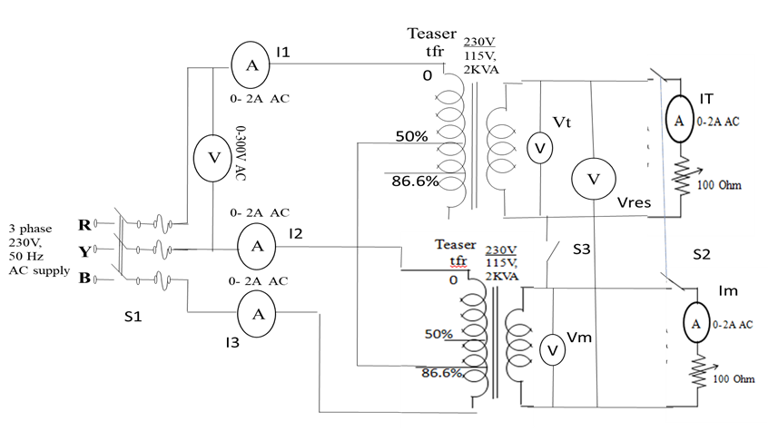

PRE TEST:

1. Two phase supply means two voltages with -
2. **90 degree phase shift** B. 180 Degree phase shift
3. Balanced three phase connections means-
4. **120 degree same current phase difference**
5. 60 degree same current phase difference
6. Scott connection is useful for convrting-
7. **Three phase to 2 phase**
8. Three phase to 1 phase

PROCEDURE:

1. Connect the circuit as shown in the diagram.
2. Keep the load switches OFF and switch on the 3 phase supply.
3. Note the readings as per the observation table.
4. Switch on the 2 phase load and adjust it such that equal current flows in the two secondaries.
5. Note down the currents on secondary side and primary side.
6. Decrease the load and switch off the supply.

POST TEST:

1. No of transformers rquired in scott connection-
2. **2**  B. 4
3. Phase shift between main transformer primary voltage & teaser transformer primary voltage is-
4. 0 degree B. **90 degree**
5. Teaser transformers primary turns=
6. **Main transformer Py turns X √3/2**
7. Main transformer Py turns X 1/2

REFERENCES:

1. Nagrath and Kothari, “Electrical Machines”, Tata Mc Graw Hill, New Delhi.

2. J. B. Gupta, “Electrical Machines”, SK Kataria and Sons, New Delhi.

3. A.E.Clayton, “DC Machines”, Mc Graw Hill publication, 3rd Edition.

4. M. G. Say. “Performance Design of AC Machines”, CBS Publishers, 3rd Edition.